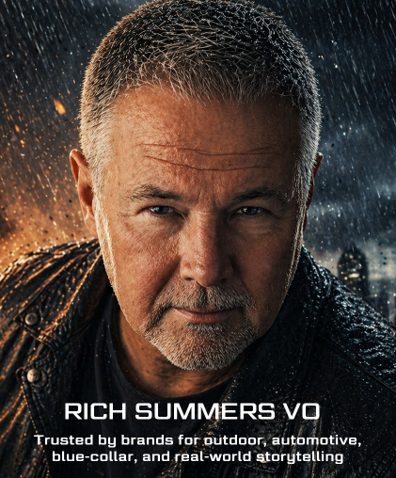
RICH SUMMERS — AUTHENTIC. CINEMATIC. MODERN WESTERN.
A Voice Forged in the Idaho Mountains
Rich Summers is a professional American voice actor whose sound blends Idaho grit, cinematic weight, and lived-in authenticity. His baritone carries texture, warmth, and a grounded Western presence — the kind of voice brands choose when they want their message to feel real.
Rich specializes in commercial voiceover, automotive advertising, brand storytelling, corporate narration, documentary work, and character-driven reads. Whether the tone calls for rugged masculinity, quiet emotional gravity, or a contemporary conversational style, Rich delivers performances that resonate with modern audiences.
The Modern Western Sound Brands Trust
Today’s listeners don’t want a polished announcer — they want a voice with truth in it. Rich’s signature sound is:
- Authentic & relatable — a real human presence, not a manufactured veneer
- Gritty & grounded — shaped by mountain life and Western storytelling
- Warm & trustworthy — steady, believable, and emotionally connected
- Cinematic when needed — bold, mythic, and visually driven
- Conversational & contemporary — perfect for today’s natural commercial style
From rugged outdoor brands to heartfelt healthcare campaigns, from high-energy retail to subtle luxury, Rich adapts to the emotional core of your message.

Broadcast-Ready Studio
High-end audio is non-negotiable — and Rich delivers it every time.
- Sennheiser MKH-416 microphone for world-class clarity
- Ultra-quiet, acoustically treated isolation booth
- Source-Connect Standard, Zoom, and phone patch for live direction
- Professional editing & mastering
- Royalty-free music & SFX libraries
- Peak-normalized, broadcast-ready files delivered fast
Your session can be directed from anywhere, and your audio arrives polished, consistent, and ready for the mix.
Trusted by National Brands, Agencies & Production Teams
Rich’s voice has supported campaigns, narrations, and character work for clients across industries — including:
Garmin Aviation • Daily Wire+ • Chicago Recording Company • Magpul Industries • OshKosh Corporation • Northwestern Memorial Hospital • Uplift Games • Domini Games • PS Seasonings • Dirty Robber Productions • Fresca Foods • KVell Fitness • Intermountain Gas • Old Wisconsin Sausage • Wonder Works Studios • Visit Parks USA • Texas Women’s University • Audi Bend • Beynon Sports • Castlebury Financial • Sparklight Advertising • Radio Forecast Network • Silverhawk Realty • Vet Tix • Ultra Touch • H&M Meats • E Motors West • Big Idea Company • Dexterra • Laughlin Constable • Warner Music Nashville • and many others.
Rich is also a Voices Top Talent, with a long track record of 5-star projects and repeat clients who rely on his consistency, professionalism, and instinctive storytelling.
If Your Brand Needs a Voice with Grit, Authenticity, and Cinematic Presence…
Rich Summers delivers a sound that feels powerful, real, and unmistakably Western — the kind of voice that cuts through the noise and leaves a mark.


Voice Actor, Rich Summers VO
208.573.3442 | rich@richsummersvo.com
www.richsummersvo.com

